Market Monitor - Burkina Faso - 2026-04

Highlights
Staple food prices in Burkina Faso continued their strong deflationary trend in April 2026, with costs decreasing both month-over-month and significantly compared to the previous year.
The national average cost of the food basket fell by 1.3% since March 2026 and is now 28.5% lower than in April 2025.
Prices for major cereals continued to fall, with millet (↓3.6%) and white maize (↓2.3%) seeing the largest monthly drops. In contrast, beans (niebe) were the only commodity to record a price increase (↑1.5%) this month. Year-over-year, all staples are significantly cheaper, led by maize (↓35.7%) and beans (↓31.0%).
Key Drivers:
- Significant year-over-year price deflation across all monitored staples, with prices for maize (↓35.7%), beans (↓31.0%), and sorghum (↓28.4%) all recording substantial decreases.
- Continued month-over-month price reductions for major cereals, including millet (↓3.6%) and maize (↓2.3%), which drove the overall food basket cost down.
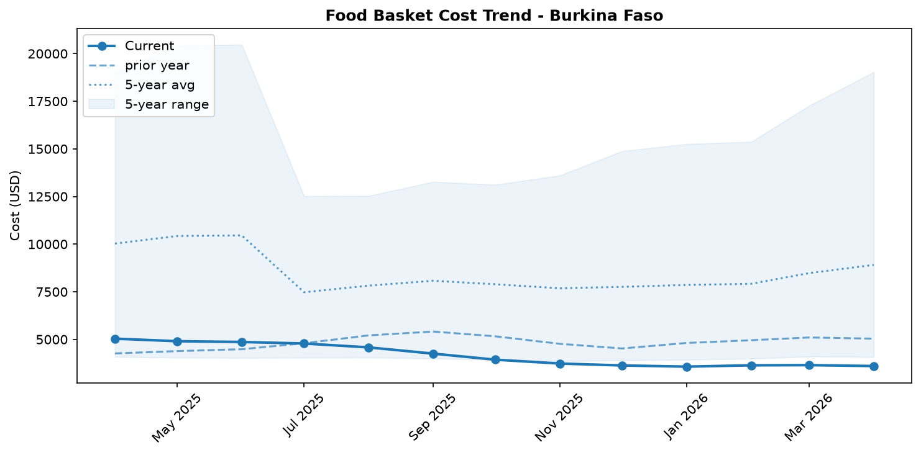
Food basket cost trend

Market Overview
Staple food markets in Burkina Faso continued to exhibit a strong deflationary trend in April 2026, providing a complex picture when set against the country's ongoing humanitarian crisis. The average cost of the monitored food basket fell by a significant 28.5% compared to the same period last year and registered a further 1.3% decrease from March 2026. This trend is primarily driven by sustained, broad-based price reductions across major cereals, reflecting a potential improvement in supply following a relative easing of security in 2025 that facilitated some agricultural and market activities.
However, these favorable price movements at the national level do not necessarily translate to improved food security for all. The country continues to grapple with a severe security crisis that, as of April 2026, has left 2 million people internally displaced and 1.7 million facing food insecurity. For many vulnerable households, particularly the displaced, weak purchasing power remains a critical barrier to accessing food, even as market prices fall. The current market dynamics thus highlight a growing divergence between food availability at a macro level and the economic ability of the most vulnerable populations to access it.

Commodity Analysis
The downward trend in the overall food basket was underpinned by continued price decreases for most monitored cereals in April 2026. Millet experienced the sharpest month-over-month decline, falling by 3.6%, and remains down 27.1% year-over-year. White maize, a key staple, also contributed significantly to the deflation, with its price dropping 2.3% from March and a substantial 35.7% from the previous year. The price of white sorghum was perfectly stable month-over-month but aligns with the broader annual trend, showing a large 28.4% year-over-year decrease. Local rice proved the most stable cereal, with only a minor 0.6% monthly price reduction; however, its 15.4% year-over-year drop is still notable.
In contrast to the cereals, beans (niebe) were the only commodity to register a month-over-month price increase, rising by 1.5%. This slight uptick suggests a recent tightening in the bean market, potentially due to localized supply factors. Despite this monthly increase, the price of beans remains 31.0% lower than in April 2025, indicating that the recent rise follows a period of major price correction. The dominant downward pressure from major cereals, however, continues to dictate the overall direction of the food basket cost.
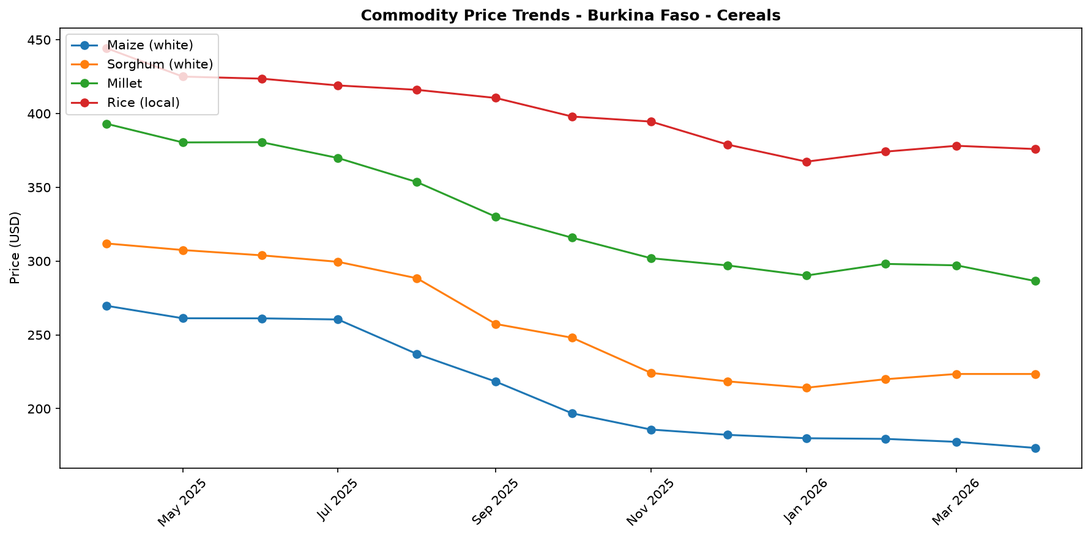
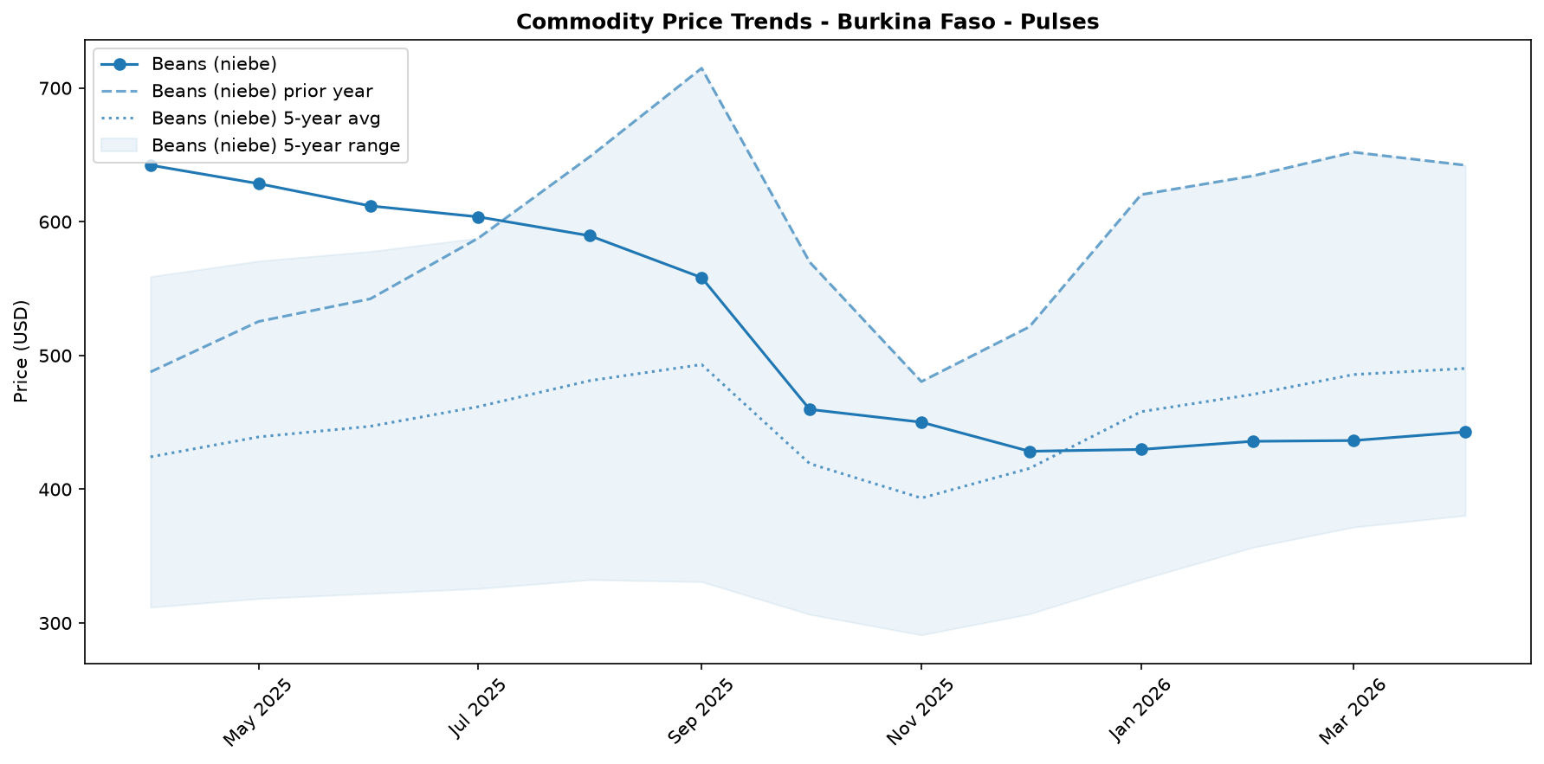

Regional Highlights
At the national level, market trends appear positive, with the cost of the staple food basket decreasing by 1.3% month-over-month and 28.5% year-over-year. This national average, however, masks severe regional disparities in food access and security.
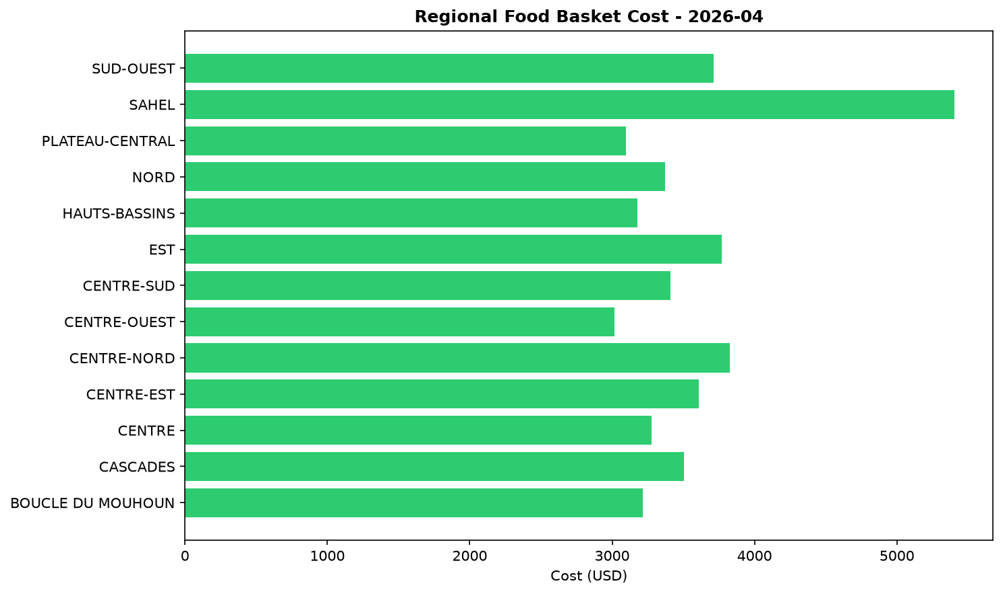
A stark contrast is evident in Karo-Peli Province. Despite the national deflation, households in this region continue to face Crisis-level food insecurity (IPC Phase 3). Contextual reports from April indicate that this is not an issue of food availability on the market, but one of access. Households have reportedly depleted their own food stocks from the last harvest and possess weak purchasing power, rendering them unable to buy food even at reduced prices. While food assistance provided in March 2026 likely offered temporary relief to a significant portion of the population, the underlying economic vulnerability persists. The situation in Karo-Peli underscores a critical disconnect between favorable national price trends and the severe food access constraints faced by conflict-affected populations with limited income.

References
- [rw_4208918] ReliefWeb (2026-04-22) UNICEF Executive Director Catherine Russell’s remarks at the Humanitarian Dialogue – Humanitarian Priorities for Children in 2026
https://reliefweb.int/node/4208918
- [rw_4208090] ReliefWeb (2026-04-17) Rapport final indice de fonctionnalite des marches 2025
https://reliefweb.int/node/4208090
- [rw_4207091] ReliefWeb (2026-04-13) WFP Burkina Faso Country Brief, March 2026
https://reliefweb.int/node/4207091
- [rw_4207009] ReliefWeb (2026-04-13) Burkina Faso Key Message Update: Crisis (IPC Phase 3) persists in the north and east amid the lean season, March - September 2026
https://reliefweb.int/node/4207009
- [rw_4206645] ReliefWeb (2026-04-09) Integrating nutrient supplements and WASH into agriculture programs improves child micronutrient status in Burkina Faso
https://reliefweb.int/node/4206645
- [rw_4205328] ReliefWeb (2026-03-31) West and Central Africa: Latest Events at a glance (24 - 30 March 2026)
https://reliefweb.int/node/4205328
- [rw_4205099] ReliefWeb (2026-03-30) Bi-monthly Pastoral Surveillance bulletin in the Sahel N°35 / October-November 2025
https://reliefweb.int/node/4205099
- [rw_4205066] ReliefWeb (2026-03-30) Bi-monthly Pastoral Surveillance bulletin in the Sahel N°36 / December 2025 - January 2026
https://reliefweb.int/node/4205066
- [rw_4204694] ReliefWeb (2026-03-27) Situation in Central Sahel, Liptako Gourma and Coastal Countries - DTM Monthly Dashboard #65 (February 2026)
https://reliefweb.int/node/4204694
- [rw_4204486] ReliefWeb (2026-03-26) UNICEF West and Central Africa Region Humanitarian Situation Report No. 2 (End of Year), 31 December 2025
https://reliefweb.int/node/4204486
- [seerist_1028284] Seerist (2026-04-24) Government purchase of stake in mine underlines HIGH regulatory, contract risks for mining operators
- [seerist_1028238] Seerist (2026-04-21) Big Picture series: Hard currency decisions – Sahel juntas unlikely to abandon CFA franc
- [seerist_1028144] Seerist (2026-04-14) Big Picture series: Strait of Hormuz disruption to drive acute fiscal, supply chain challenges in Africa
- [seerist_1027861] Seerist (2026-03-20) Big Picture series: Beyond health – the implications of the America First Global Health Strategy

